select * from orders;

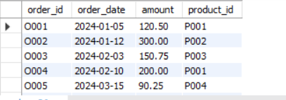

select extract(month from order_date) from orders;

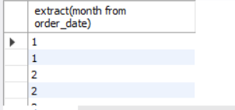

select sum(amount) as revenue from orders;

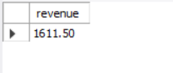

select product_id,min(order_id) from orders group by product_id;

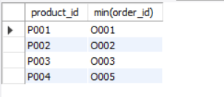

select order_id from orders where product_id="P001";

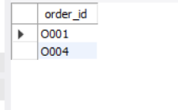

select count(distinct order_id) from orders;

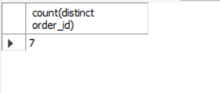

select amount from orders order by amount; # ascending

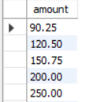

select product_id from orders where order_date between '2024-01-01' and '2024-12-12';

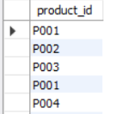

select sum(amount) from orders group by month(order_date);

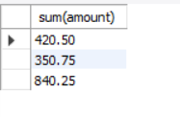

SELECT

YEAR(order_date) AS year,

EXTRACT(MONTH FROM order_date) AS month,

SUM(amount) AS total_revenue,

COUNT(DISTINCT order_id) AS order_volume

FROM orders

WHERE order_date BETWEEN '2024-01-01' AND '2024-03-31'

GROUP BY YEAR(order_date), EXTRACT(MONTH FROM order_date)

ORDER BY year, month;

